**Worksheet 1.2**

**Student Name:** Vivek Kumar **UID:** 21BCS8129

**Branch:** BE-CSE (LEET) **Section/Group:** 20BCS-809/A

**Semester:** 4th Sem **Date of Performance:** 20/02/2022

**Subject Name:** MPI Lab **Subject Code:** 20CSP-253

**1. Aim/Overview of the practical:**

Addition of two 16bit numbers, sum 8 bits.

**2. Task to be done:**

Write the 8085 Micro Processor program to calculate the addition of two 16bit numbers.

**3. Apparatus/Simulator used (For applied/experimental sciences/materials-based labs):**

**Software Requirements:**

1. 8085 Jubin simulator version 2 (Microprocessor Simulator)
2. Java (jdk/ jre1.8.0_321)

**Hardware Requirements:**

1. Processor –Any suitable Processor
2. Main Memory - 128 MB RAM
3. Hard Disk –minimum 20 GB IDE Hard Disk
4. Removable Drives–1.44 MB Floppy Disk Drive –52X IDE CD-ROM Drive
5. PS/2HCL Keyboard and Mouse

**4. Algorithm (For programming-based labs):**

**Algorithm:**

1. Load the first number pair from memory location 3000 and 3001 to HL Pair.
2. Exchange The HL content to DE Pair.
3. Load the first number pair from memory location 3002 and 3003 to HL Pair.
4. Move the content of E register to accumulator.
5. Add L register and store in Accumulator.
6. Move the content of accumulator to L register.
7. Move the content of D register to accumulator.
8. Add H register and store in Accumulator.
9. Move the content of accumulator to H register.
10. Store the HL pair data in Memory address 3004 and 3005.

**5. Description/ Code:**

**Example: 1**

# ORG 2000H

LHLD 3000

XCHG

LHLD 3002

MOV A,E

ADD L

MOV L,A

MOV A,D

ADD H

MOV H,A

SHLD 1004

HLT

# ORG 3000H

# DB 12, 11, 11, 12

**Example: 2**

# ORG 2000H

LHLD 3000

XCHG

LHLD 3002

DAD D

SHLD 3004

HLT

# ORG 3000H

# DB 12,42,99,12

**6. Result/Output/Writing Summary:**

**Example: 1**

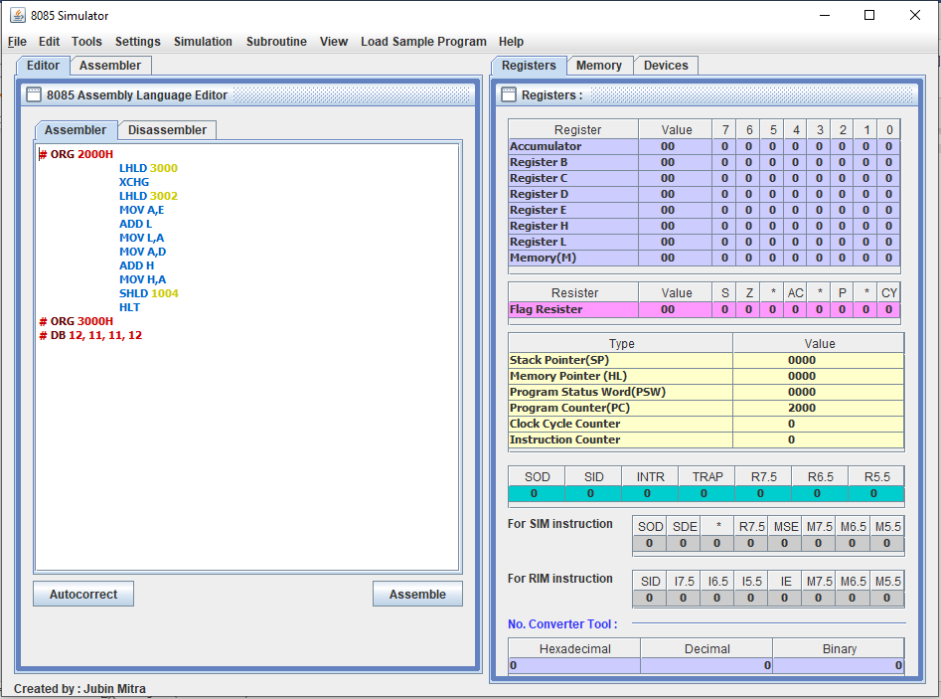

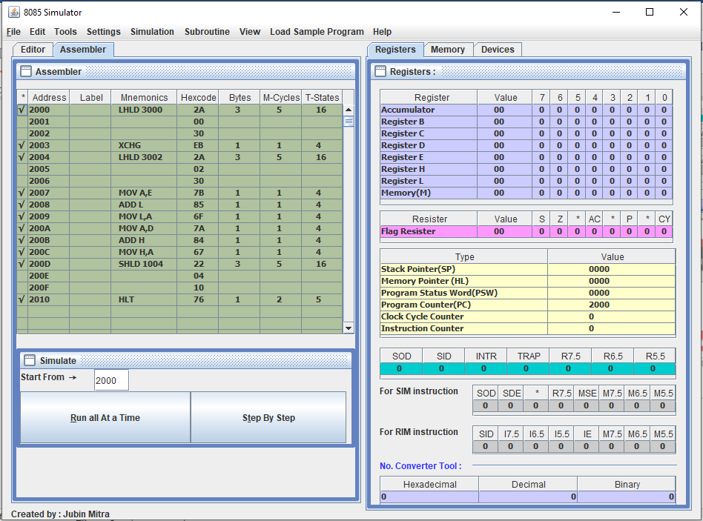

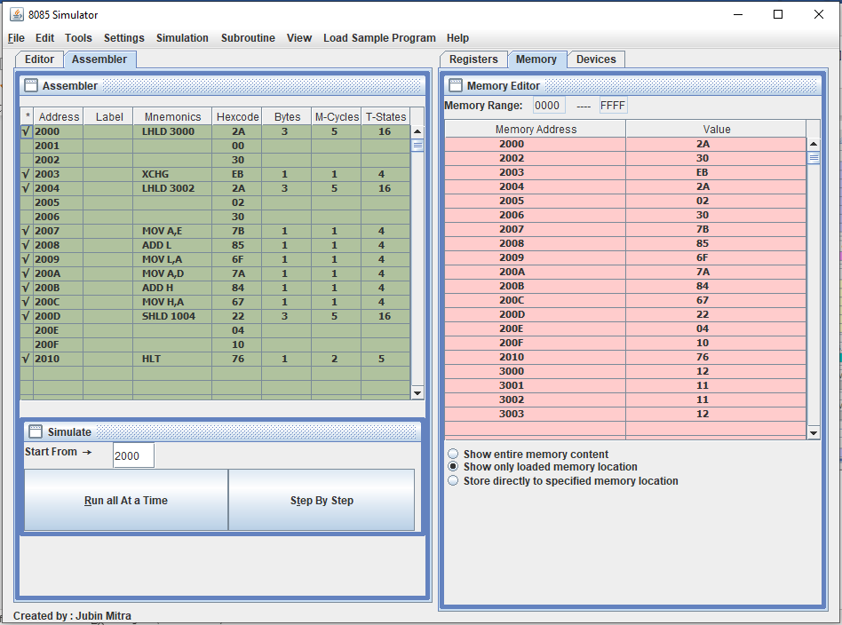

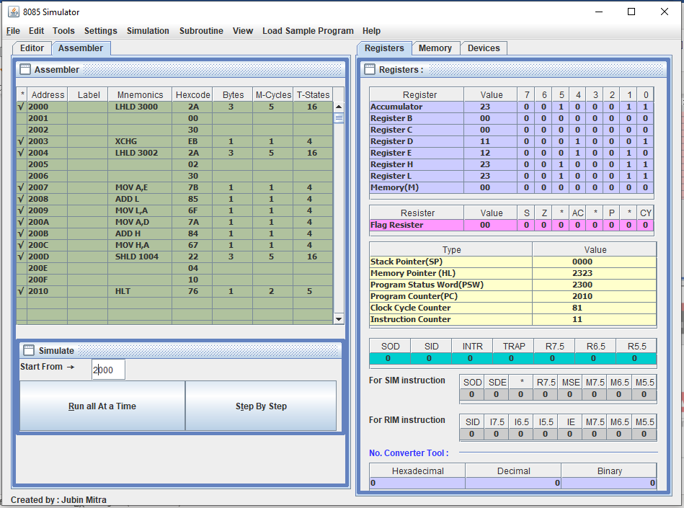

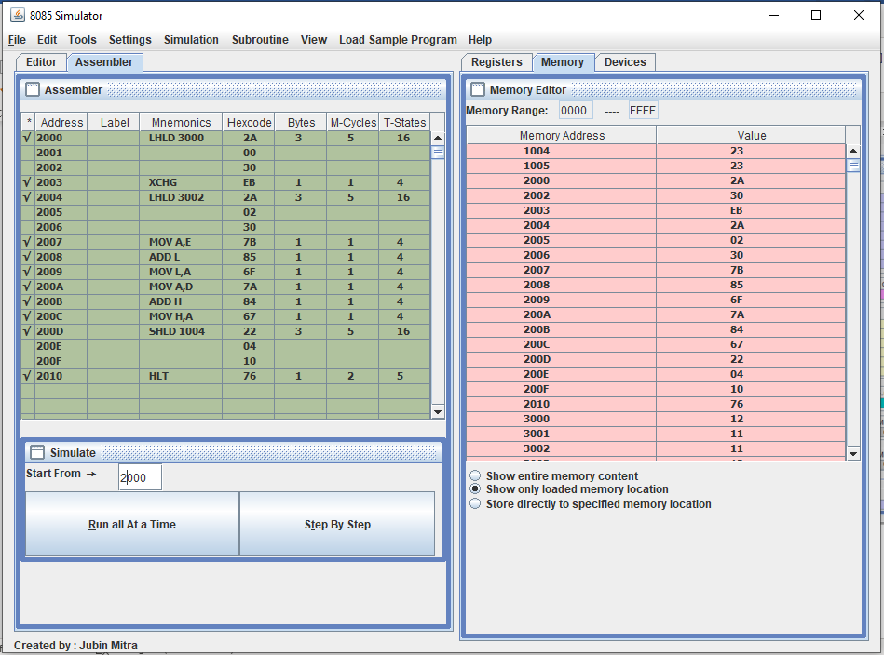

**Example: 2**

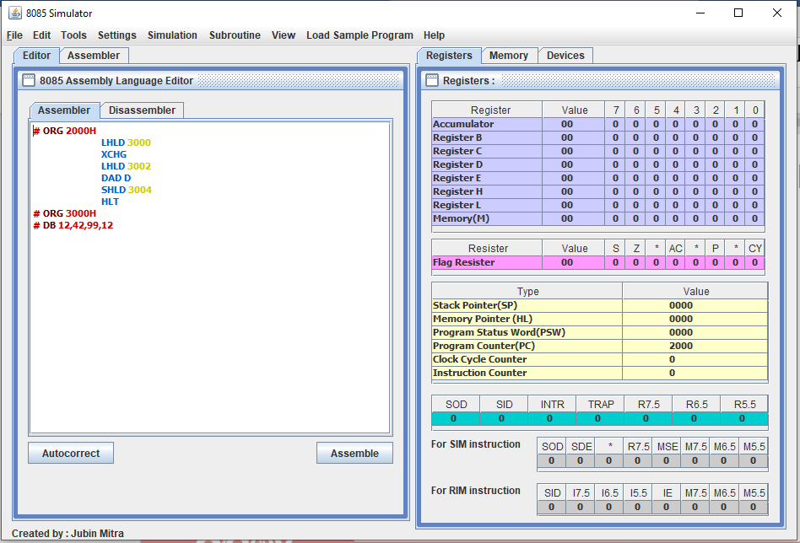

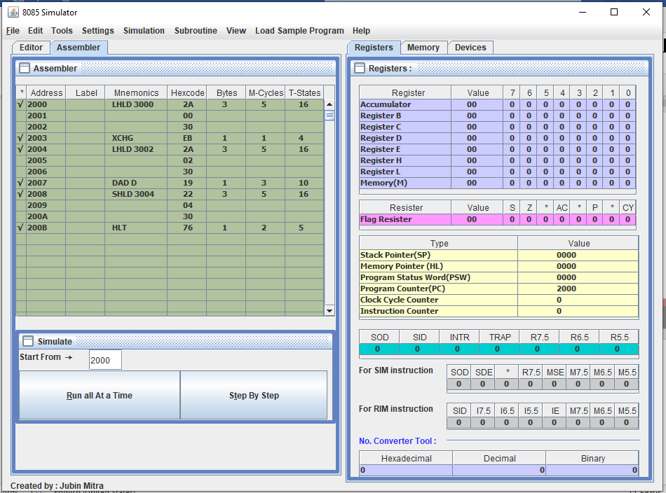

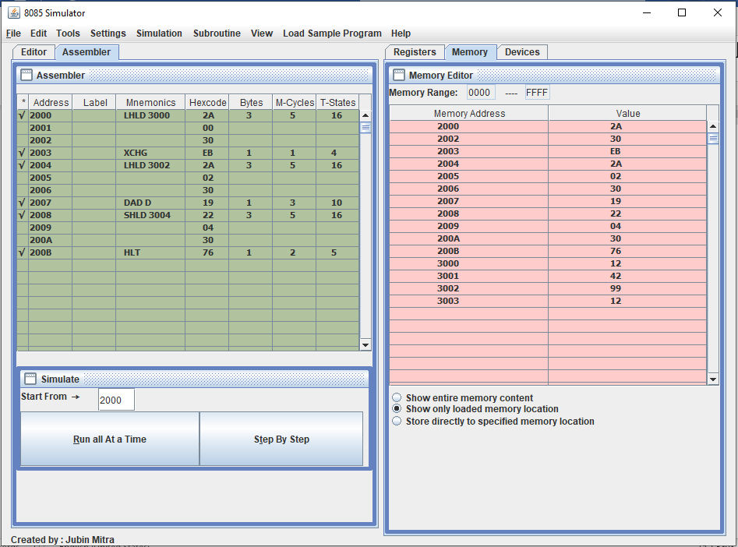

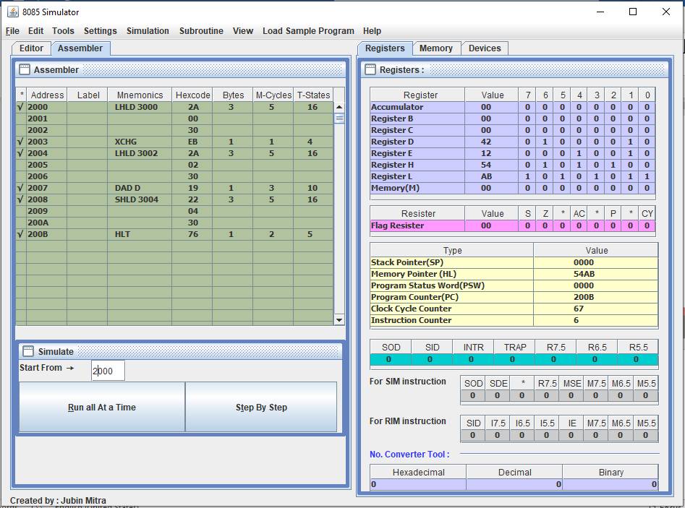

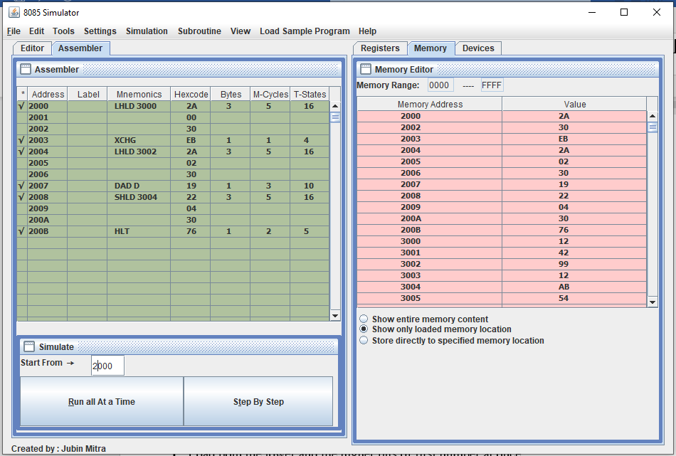

**Learning outcomes (What I have learnt):**

**1.** Learnt how to do the 8085-microprocessor programming.

**2.** Learnt how to add the two 16bit numbers.

**Evaluation Grid (To be created as per the SOP and Assessment guidelines by the faculty):**

|  |  |  |  |
| --- | --- | --- | --- |
| Sr. No. | Parameters | Marks Obtained | Maximum Marks |
| 1. |  |  |  |
| 2. |  |  |  |
| 3. |  |  |  |
|  |  |  |  |